**语法新题型填空规则**

**Part I 概述**

**\*给提示词（一空可填多词）**

**1. 动词**

a. 谓语动词，考察时态语态

b. 非谓语动词，填不定式、动名词、分词（高一下重点）

**2. 形容词或副词，填比较级或最高级**

**\*无提示词（一空一词）**

1. 情态动词

2. 连接词

1）并列结构连接词：and (很少考), or, but

2）三大从句引导词（状语从句，定语从句，名词性从句）

3）强调结构 “It is/was + 强调成分 + that ...”

3. 介词（注意积累词汇搭配）

4. 代词（人称代词、物主代词、反身代词、指示代词、不定代词）

5. 冠词(a, an, the)

**Part II 例题**

* **给提示词**

**1. 动词**

(1) 充当谓语，选择准确的时态和语态

*Want to know more about global warming and how you can help prevent it? Doctor Herman Friedman, who is considered a leading expert on the subject, ________ (speak) at Grayson Hall next Friday.

(will speak)

*When electricity __________ (discover) in the late 1800s, people living in remote areas began to use them to produce electricity.

(was discovered)

(2) 非谓语，填不定式/动名词/分词（高一下重点）

*Traffic jams can cause many serious problems, forcing the system _________ (close) down for repair.

(to close)

*Different forms of maps are appearing. They allow independent travelers ________ (get) local knowledge of places they are visiting, from the official to the unusual.

(to get)

*The Irish are famous for _________ (be) warm-hearted and friendly. Oscar Wilde, a famous Irish writer, once said that the Irish were “the greatest talkers since the Greeks”.

(being)

*_________ (imitate) role models is like __________(use) training wheels on a child’s bicycle; they help you get going, but once you find your own balance, you fly faster and farther without relying on them.

(imitating, using)

*But the panic that filled my shocked heart in that awful moment was for the nine cats that shared my home after (25)_________(save) from situations of ill-treatment and abandonment .

(being saved)

**2. 形容词或副词，填比较级或最高级**

*They are Wellman, whose legs were permanently injured nine years ago in a rock-climbing accident, and Corbett, an experienced rock climber. Together, they climbed up Half Dome, the famous 2,000-foot rock in the Yosemite National Park, through one of _________ (difficult) routes.

(the most difficult)

*Cassandra Feeley finds it hard to manage on her husband’s income. So this year she did something more than a hobby: She planted vegetables in her yard. She is among the growing number of Americans who, driven by __________(high) living costs and a falling economy, have taken up vegetable gardening for the first time.

(higher)

*Back in 2014, the UK was given the title of the “loneliness capital of Europe” by The Telegraph. A survey carried out by the newspaper found that British people were ________ (likely) to get to know their neighbours or build strong relationships with people than those from other European countries.

(less likely)

* **无提示词**

**1. 情态动词**

*Think about the different ways that people use the wind. You _________ use it to fly a kite or to sail a boat.

(can)

*When I caught my breath, I realized I saved someone’s life, which is what I ______ do.

(should)

*Looking at the painting with the microscope, I came across the tiny body of a grasshopper covered in the paint, so it ______ have occurred(出现) in the wet paint back in 1889.

(must)

**2. 连接词，并列结构连词、三大从句引导词（状语从句，定语从句，名词性从句；名词性从句高一下重点）、强调结构**

*“We’ve become so accustomed to noise, there’s almost a deep prejudice(偏见) against the idea that silence might be beneficial. ________ you tell someone to be quiet, you sound like an old man.

(If)

*Van Gogh painted Olive Trees in 1889, the year after his falling out with his friend Gauguin, _____ may have led to his famous act of self-mutilation in the history of art: cutting off his own ear.

(which)

*Career experts say such habitual complainers are highly contagious, _______ attitude can easily affect an entire team in a company. (whose)

*______ is considered to be proper table manners in one country is likely to be seen as rude in another. (what)

***注意多空的情况，如：***

*Called “Tabikaeru: Travel Frog”, the main character of the game is a frog that goes on adventures around Japan. Players collect clovers(四叶草) that grow in the frog’s garden ________ ________ they can use them to buy supplies for the frog’s journeys.

(so that)

**3. 介词**

*Beliefs change, they mature and grow just _______ a child. (like)

*Modern ideas are beginning to influence the Eskimos, but not enough to make much difference ________ their way of life. (to)

*Before returning home at night, he had a bath and changed back _______ his suit. (into)

*In the 1840s the main crop, potatoes was affected by disease and about 750,000 people died _____ hunger. As a result, the population fell from 8.2 million in 1841 ______ 6.6 million in 1851.

(of, to)

***注意多空的*情况，如：**

*These days , many totem(图腾) poles no longer exist _______ ______ decay and rot.

(because of)

*It’s possible that some dreams of the future may still be ______ ______ our reach.

(out of)

**3. 代词（人称代词、物主代词、反身代词、指示代词、不定代词）**

*Every morning, the gardener would fill up the two buckets. Then he would carry __________ along the path, one on each side, to the flowerbeds. (them)

*William Butler Yeats, a most famous Irish writer, was born in Dublin on June 13, 1865. ____________ childhood lacked the harmony that was typical of a happy family. (His)

* While some complaints might be reasonable, _______ are taken from thin air（子虚乌有）.

(others)

**5. 冠词(a, an, the)**

The result is that today there are two “Irelands”. Northern Ireland, in the north, is part of the United Kingdom. The Republic of Ireland, in the south, is ________ independent country.

(an)

**Part III 可填词汇总**

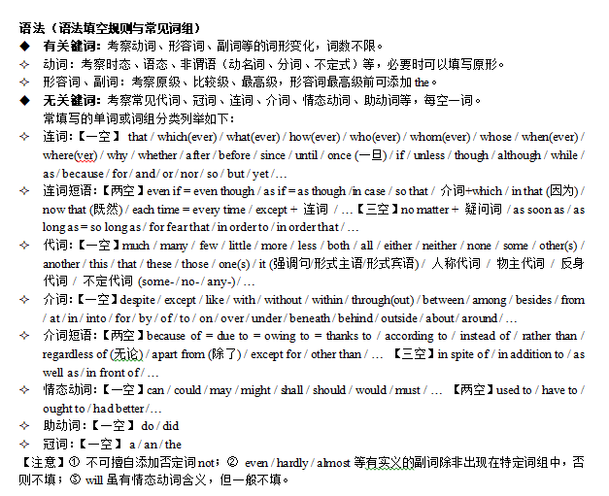

**Part IV 高考核心语法专题汇总**

1. 动词时态语态 (tenses and voices of verbs)
2. 情态动词（modal verbs）
3. 定语从句（attributive clauses）
4. 状语从句（adverbial clauses）
5. 名词性从句（noun clauses）
6. 不定式（infinitives）
7. 动名词（gerunds）
8. 分词（participles）
9. 倒装（inversion）
10. It强调句 （emphatic sentence）

**Part VI 模拟题示例**

**2021松江二模-语法填空题**

**How to Become a Morning Person?**

You have grand ambitions: to start a business, to write a book. But chances are you work long hours, or household responsibilities consume your days. By the time you finish all you have to do, you will have had no energy (21)_________ anything you want to do beyond turning on the TV.

Yet some busy people do make time for their priorities. The secret is giving the most attention to (22)_________ at the very beginning of a day. They get up earlier than they have to. Morning by morning, they make progress on something (23)_________ matters.

It’s not fun to force yourself out of bed, but these early hours are often the best time to do things for yourself. With a little schedule reorganization, (24)_________ (become) a morning person is more doable than you think.

I first learned that mornings (25)________ be transformational years ago, when I was studying a busy lawyer’s schedule. She wanted to spend more time with her son, but she had little control over when she left work. This state of affairs kept her sad (26)________ she realized she and her son were both early risers and the morning time could be made full use of. After thinking it through, the lawyer decided to get up even earlier. Then, when the boy stepped into the dining room, she (27)_________ (finish) preparing a rich breakfast so they two could enjoy the meal to the fullest together.

Mornings are also great for focused thinking. Get up an hour earlier, and you can knock out your most important task of the day. Or you can spare some time for those creative desires (28)________ (bury) deep in your heart and hard to nurture.

But many will argue: I’m not a morning person! The fact is that there are not so many true night owls. When most people take an honest look at (29)________ they’re spending the hours before bed, they’ll find they have wasted much time on the TV programs they don’t mean (30)_______ (watch). Also, they often browse through photos on social media of people they didn’t like in high school anyway.

A better approach is to sleep earlier, rise earlier and turn unproductive evening hours into productive morning hours.